STUDENT_MASTER Table Structure for MS Access

Column Name | Data Type | Width | Primary Key?
STUDENT_ROLL_NO | Number | 8 | Yes
STUDENT_NAME | Text | 30 | No
STUDENT_GENDER | Char | 1 | No
MATHS_MARKS | Number | 3 | No
PHYSICS_MARKS | Number | 3 | No
CHEMISTRY_MARKS | Number | 3 | No
COMPUTER_SCIENCE_MARKS | Number | 3 | No

Student Data Report Format

Roll # | Name | Gender | Marks |  |  |  | Total
Roll # | Name | Gender | Maths | Physics | Chemistry | Computer Science | Total

Objective

To generate a student data report as per the format given above in a file using the base for the sample code. Given below is the package structure that must be followed for the sample code to be written during the course, followed by a zip of the code base.

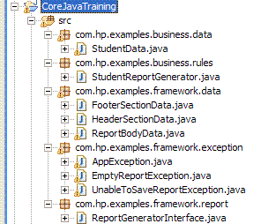

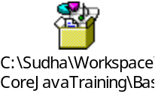
Important Notes for the Trainer

- The idea of this approach is to eliminate “spoon-feeding” and make the trainees as independent and comfortable as possible with respect to basic OO and Java concepts.

- It is important for the trainer to understand the base code from the technical perspective but also its features so that s/he can provide appropriate training.

- On Day 4, the trainer would enable the trainees to write the base code by just explaining the framework and the approach to them and by just guiding them whenever they have doubts. Following this session, the trainer would ask the trainees to write the code to generate the Student Data Report. During this session also, the trainer would just explain the concepts and provide minimal guidance.

Features of the Base Sample Code

- The base code is meant for the trainer to understand the training requirements and is not meant for the trainees.

- The trainees will write this code as well before writing code to generate the Student Data Report.

- The base code already covers the following concepts in the planned topics:
- Interface
- Abstract class
- Inheritance (incl. the keywords super, private public, protected)
- Constructor overloading
- A fairly deep package structure with at least 4 levels and import
- The throws keyword
- The String class
- The ArrayList class

- The base code is such that it will force the usage of the following concepts while the trainees code to generate the Student Data report:
  - Exception handling - try, catch, finally, throw
  - Calendar and Math
  - Sorting of Collections

Other Business and Technical Requirements

- The user should pass NAME/TOTAL to indicate whether to sort the report on ascending order of student name or on descending order of student total. This value must be represented as a static final value in the code.

- The report footer must have the system date printed in the DD-Mon-YYYY format. It must be represented as a Calendar object in the code.

- The sample must follow the DAO design pattern i.e. it must have a DAO to make DB calls and to perform data retrieval (wrt the STUDENT_MASTER Table) using JDBC.

- The data retrieved from the DB to display the report must be stored in an ArrayList which would be passed back from DAO to the main class.

- All classes of the com.hp.examples.framework packages must be placed in a JAR named framework.jar and all classes of the com.hp.examples.business packages must be placed in a JAR named studentmaster.jar.

